VBH Holding AG creates a solid basis for further growth with operating profits for 2010

Korntal-Münchingen, March 31, 2011 – After the economy-driven setbacks in the previous year, in 2010 VBH Holding AG, Europe’s largest trading house for window and door fittings, again generated Group sales of approximately € 800 million. It thus exceeded the previous-year figure of € 755.1 million by 5.9%. Adjusted EBT rose by as much as 33% to €13.2 million. As a result of one-time items such as corrections on goodwill and discontinuation of the Australian market, the Group generated a net loss of the year of €1.2 million. VBH Holding AG is thus using the good result in 2010 to clear up the after-effects of the economic crisis, thus creating a solid basis for further growth.

Adjusted EBIT totalled € 21.6 million (previous year: € 17.2 million), representing an adjusted EBIT margin of 2.7% (previous year: 2.3%), Adjusted EBITDA rose by 23.2% to €27.6 million. Adjusted EBT increased by approximately 33% to €13.2 million. This already includes the losses from the companies being restructured in Belgium, Italy and China. In the context of the annual measurement of the holdings, corrections on goodwill were taken not impacting liquidity that negatively impacted the Group result by € 8.7 million. In addition, there is an expense of € 0.9 million resulting from discontinuing the market presence in Australia. As a result of one-time effects, the Group generated a net loss of the year of € 1.2 million. Working capital increased in line with sales, by 9.6% to €183.8 million.

In the Group the equity ratio remained stable, at 36% after 37% in the previous year. Due to the strong sales upturn in the last quarter, cash flow in the reporting year was negative at €16.8 million, the result of building up inventories and receivables.

Share price develops in a stable fashion

In line with the economic and strategic trend, the VBH share price developed in a stable fashion in 2010. In June 2010, due to lower trading volume resulting from the declining free float and lower market capitalisation, the shares of VBH Holding AG were taken out of the SDAX segment of Deutsche Börse.

Dividend proposal

The Executive Board proposed the Supervisory Board a distribution ratio of approximately 40% for the 2010 fiscal year. This corresponds to a dividend proposal of € 0.06 per bearer share (previous year: € 0.05). The proposed distribution payment is approximately € 2.9 million (previous year: € 2.4 million). With this proposed resolution, the Executive Board wants shareholders to participate appropriately in the operating result, even though there is no change to the overall objective of further reducing net debt in the Group.

Germany and Eastern Europe develop positively

The different business trends in the individual VBH regions reflect the global economic development. In Germany sales were expanded on a sustained level, from € 382 million to € 411 million. With a 7.6% increase the development was considerably better than the market as a whole (4.9%), the result of increased market share. The German window market again developed well. Renovation was the most stable area, followed by a slight upturn in new residential construction. Commercial construction also bottomed out in 2009 and is slowly firming.

With sales up 12.2% year on year, Eastern Europe is back on growth track, impacted by the good development in Russia and enormous potential for renovation.

On the other hand, sales in Western Europe fell by a further 7.4% (previous year: -21.3%) “While sales in the UK were higher, due to the generally difficult economic situation, our distribution companies in Ireland, Belgium, Greece and Italian were down year-on-year,” states Rainer Hribar, Executive Board Chairman at VBH Holding AG. “In the Netherlands, the company benefited from state intervention to revive the economy, thus reduced the sales downturn in the last quarter.” In the Other Markets segment (Asia, Middle East, Turkey, Mexico) sales were up by a pleasing 22.6%, largely driven by the company in Turkey and Singapore.

Employee performance pays off
“The company owes these good results primarily to its employees who embody our service promise of “Simply everything. Everything simple” on a daily basis with their high level of personal commitment and conscientious work,” stated Rainer Hribar. For this reason, in the crisis years, the company not only did not reduce working hours but did not discontinue one-off payments to retain jobs. Indeed the Executive Board even granted employees of the German subgroup a salary increase of 2% as of 1 October 2010 and paid out holiday and Christmas bonuses at the normal level. For many years, the workforce has already participated in the success of the company. Thus part of the amount that the current year’s result exceeds that of the previous year is paid out to employees in the form of an additional one-off payment. An initial payment on the expected bonus for the 2010 fiscal year was paid to the workforce in October.
In the past fiscal year, the VBH Group employed a total of 2,934 staff, as compared to 2,968 in the previous year. Employee numbers were increased in Germany while they declined in Western Europe due to the economic situation.

Always one idea ahead
With the good operating result, Rainer Hribar sees the company well positioned for future growth. “Our 3-pillar strategy – a broad international positioning, a successful product range and proprietary brand policy combined with our unique selling proposition with extensive services is stable and has proved successful in the recent difficult period.” The proprietary brand greenteQ has established itself on the market as a focal point with the product range, and that more quickly than expected. With more than 1,800 articles, greenteQ products now represent 6% of total sales at VBH Deutschland GmbH. VBH intends to continue vigorously with its strategy of strengthening its own brand as a supplement to the VBH product portfolio with its strong manufacturer brands and to speed up the penetration of its greenteQ products on international markets.
At the same time, the VBH service range results in a clear differentiation in the competitive environment, e.g. the unique system platform CE-fix developed in cooperation with the IFT Rosenheim, with which manufactures and suppliers of windows and doors can create all the necessary CE documents on line quickly and simply. The VBH Knowledge Database or the mobile logos app for ordering material for smart phones have been very well received. “We endeavour to make the daily work of our customers, partners and suppliers easier on an ongoing basis,” stated Rainer Hribar. “As market leader we also want to develop ideas for the future to advance the entire industry.” With the “Innovation Competition Entrances of the Future” VBH is currently examining together with architects, door manufactures and designers the question of the challenges manufacturers and planners will have to face in the future. This is set to advance innovation in this area, bringing together new techniques and materials and supporting the manufactures with new product ideas.

Outlook for 2011
For the 2011 fiscal year, the Executive Board anticipates that sales will again increase against the previous year in the Germany segment. At the same time, sales in Western and Southern Europe segments are set to decline while those in Eastern Europe should recover quickly. With exchange rates remaining constant in 2011, the Other Markets segment (Asia, Middle East, Turkey, Mexico) should also again grow significantly. In 2011, the construction industry in some countries will also benefit from government investment programs and investment incentives for climate-efficient construction. Due to the current discussion on energy, the window market in Germany is continuing to enjoy an economic boom. “For this reason, we expect a successful year overall in 2011. In total the VBH Group anticipates single-digit sales growth”, stated Rainer Hribar.

Contact:
Frieder Bangerter/CFO
Telephone +49 (0) 7150 / 15-200
Image material:

These and other images can be downloaded in print quality at
www.vbh.de.

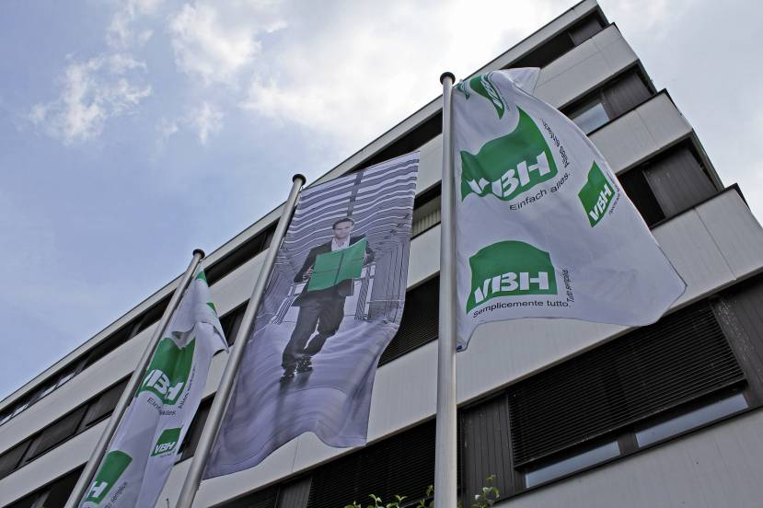
VBH Holding AG company headquarters in Korntal-Münchingen

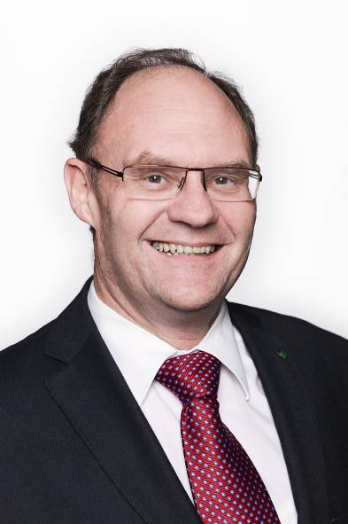 | 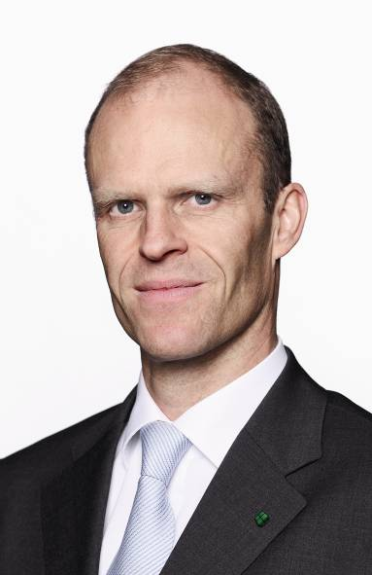
Rainer Hribar, Executive Chairman  VBH Holding AG. | Frieder Bangerter, CFO  VBH Holding AG.

